CAPITAL FORGE LEAGUE
Charitable Auction • Donor Driving • Real-Time Tracking System
Proceeds benefit helmet safety research and sports-related internships & entrepreneurship
Technical Proposal & Implementation Blueprint
Laravel 11 + Livewire 3 + Reverb + Stripe + AI Vision
Prepared for development handoff • August 2026

Document Contents
- Executive Summary & Goals
- Feature Set (Auction + CRM + Tracking + Live Display)
- UI/UX Mockups (8 screens)
- Architecture Snapshot
- Real-time with Laravel Reverb
- Stripe Payment Processing
- Livewire Component Code
- Donor Tracking Enhancements
- Implementation Roadmap

1. Executive Summary
Capital Forge League (CFL) is a 501(c)(3) nonprofit uniting military veterans and college student-athletes through gamified entrepreneurship. This proposal defines a production-ready online charitable auction platform combined with a full donor-driving CRM and public progress tracking system, purpose-built for CFL’s interns working by school and region.
All auction proceeds are designated to benefit helmet safety research and sports-related internships & entrepreneurship programs. The system draws inspiration from Givebutter’s auction, live-display, widget, and CRM capabilities while adding CFL-specific strengths: AI-powered starting-bid estimation for sports memorabilia, school/region progress visibility for interns, and a modern dark sports-tech visual language.
Primary goals: Raise funds through engaging charitable sports-memorabilia auctions that support helmet safety research and athlete/veteran entrepreneurship internships, empower interns with structured donor outreach tools, provide transparent real-time progress for all stakeholders, and process payments securely via Stripe—all within a single Laravel application.

2. Feature Set

2.1 Charitable Online Auction
- Timed silent auctions with real-time bidding (Laravel Reverb). All lots clearly marked as charitable.
- 100% of net proceeds benefit helmet safety research and sports-related internships & entrepreneurship
- AI vision analysis → market comps → suggested starting bid stored as JSON on each Lot
- Proxy (max) bidding, automatic outbid notifications, anti-sniping time extension
- Categories, featured lots, watchlists, buy-now option
- Automatic winner declaration + Stripe payment collection

2.2 Donor Driving CRM (Backend)
- CSV / JSON import of donor lists
- Assign donors to interns by Region or School
- Status pipeline: New → Contacted → Pledged → Donated → Lapsed
- Notes, last-contact, activity timeline, bulk actions
- Auction winners automatically linked to donor profiles

2.3 Public Progress & Live Display
- Live totals with goal thermometer
- Breakdown by Region (map) and by School (leaderboards + intern leaders)
- Real-time supporter feed (donations + bids)
- Full-screen Live Display mode for events (QR + text-to-donate + rotating auction highlight)

2.4 Donor Tracking (New)
- Individual donor profile with lifetime giving, engagement score, activity timeline
- Analytics view: retention, average gift, active this month, engagement scoring
- Saved segments and intern portfolio views

3. UI/UX Mockups
All screens use CFL’s dark navy / near-black base with neon green and electric blue accents, high visual hierarchy, and a modern sports-tech aesthetic suitable for both public bidders and internal interns/admins.

3.1 Charitable Auction Homepage
Hero clearly states “CHARITABLE AUCTION – Proceeds benefit helmet safety research and sports-related internships & entrepreneurship”. Featured lots, place-bid CTAs, 100% net proceeds messaging.
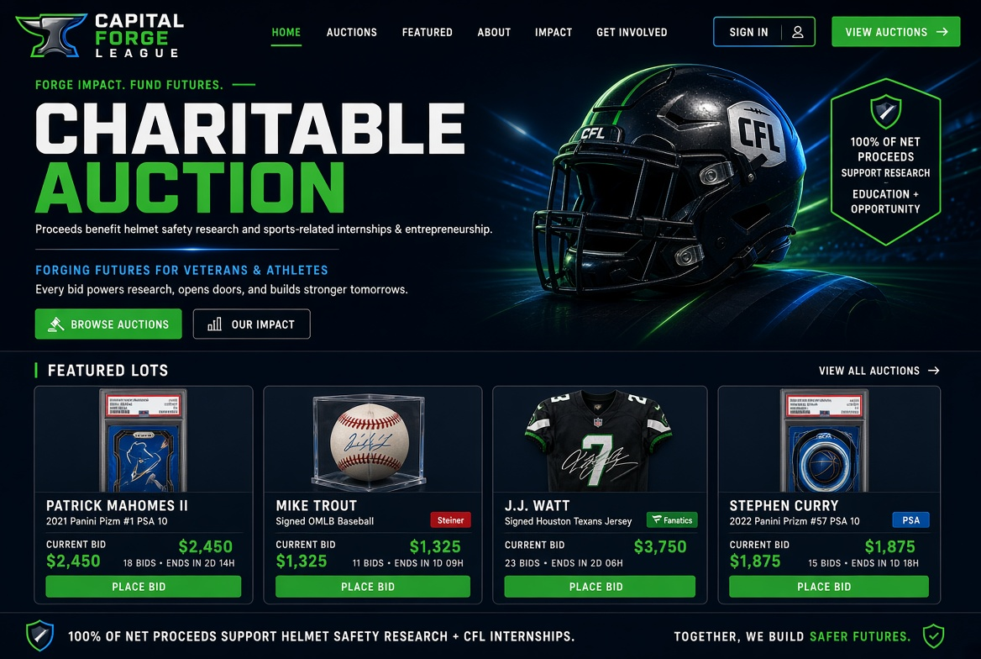

3.2 Lot Detail + AI Suggested Bid
“CHARITABLE AUCTION LOT” badge. Explicit text that proceeds from the lot support helmet safety research and sports-related internships & entrepreneurship. AI market value, suggested start, live bidding.
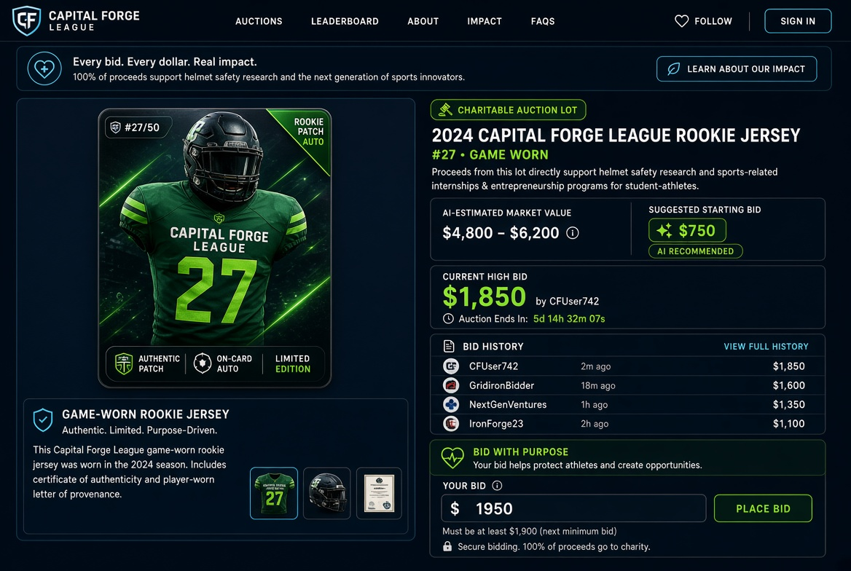

3.3 Donor Driving CRM Dashboard (kept as admin tool)
Admin/intern view: searchable donor table with Region, School, Assigned Intern, Status, Last Contact, Amount. Bulk assign + CSV import.
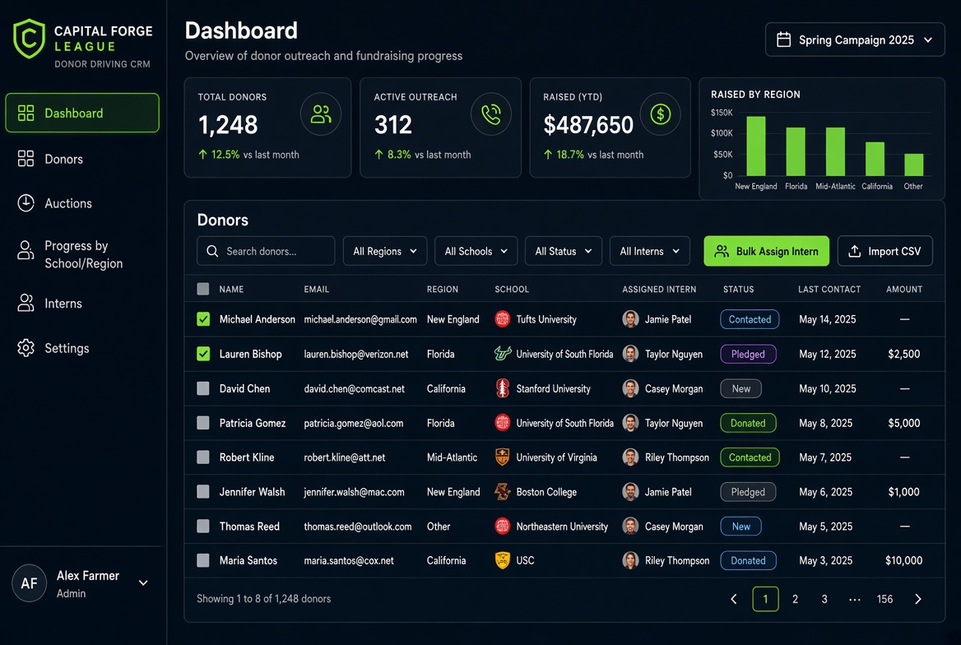

3.4 Charitable Auction Progress by School / Region
Header: “CHARITABLE AUCTION PROGRESS – Benefiting helmet safety research + sports internships & entrepreneurship”. Goal bar, region map, school leaderboards, live feed, impact icons.
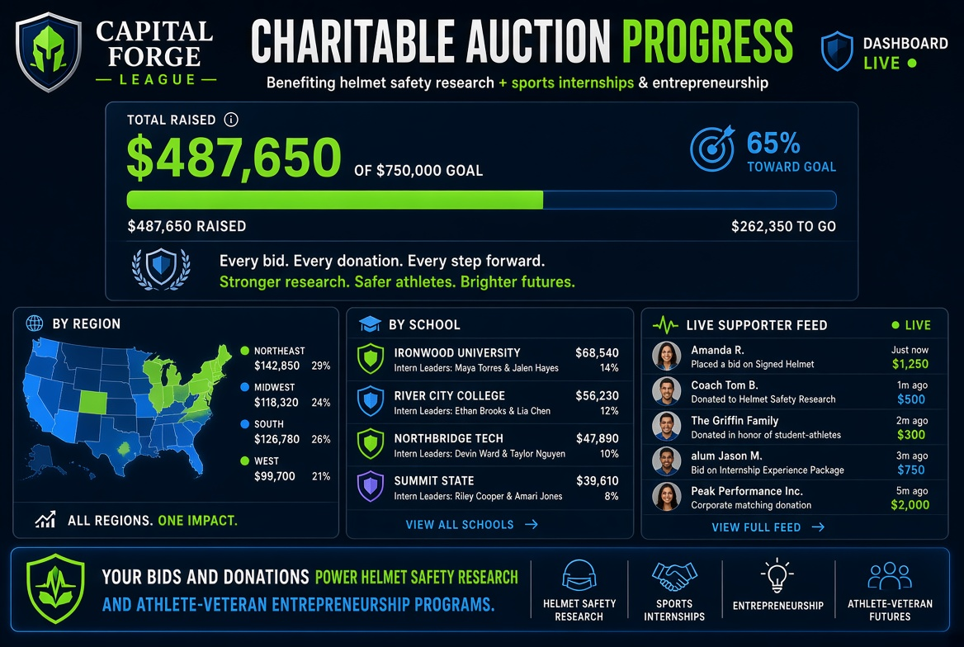

3.5 Live Display (Event Big Screen)
Full-screen “CHARITABLE AUCTION” mode. Goal thermometer, supporter feed, Scan-to-Donate, Text-to-Donate, rotating item. Clear “Proceeds benefit helmet safety research and sports-related internships & entrepreneurship” and 100% net proceeds messaging.
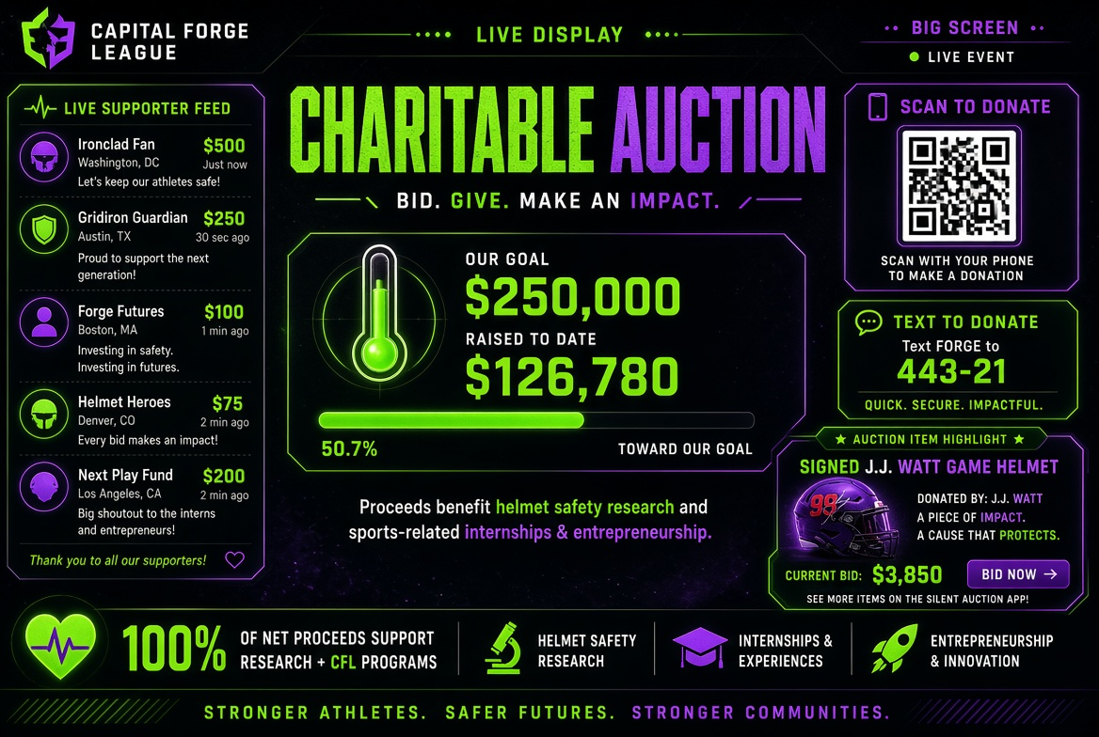

3.6 AI Item Analysis Panel
Admin tool with “CHARITABLE AUCTION LOT” badge. Proceeds support helmet safety research + internships & entrepreneurship. Identification, comps, starting-bid calculator, JSON preview, create-lot action.
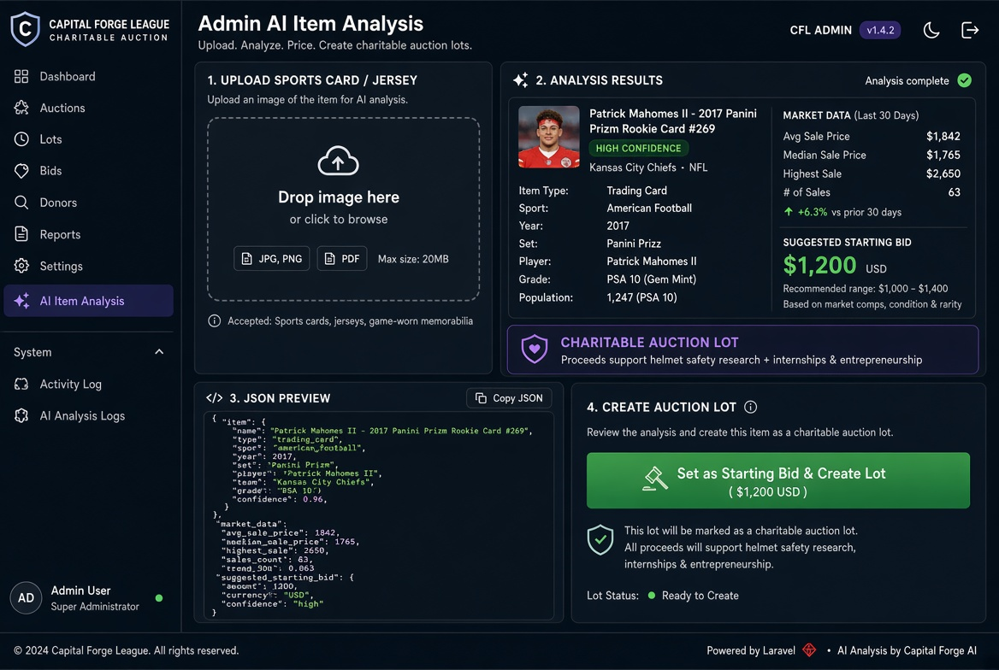

3.7 Donor Profile / Tracking Detail (dashboard)
Individual donor record: lifetime giving, status, region/school, assigned intern, full activity timeline (calls, notes, donations, auction wins), quick actions, giving chart.
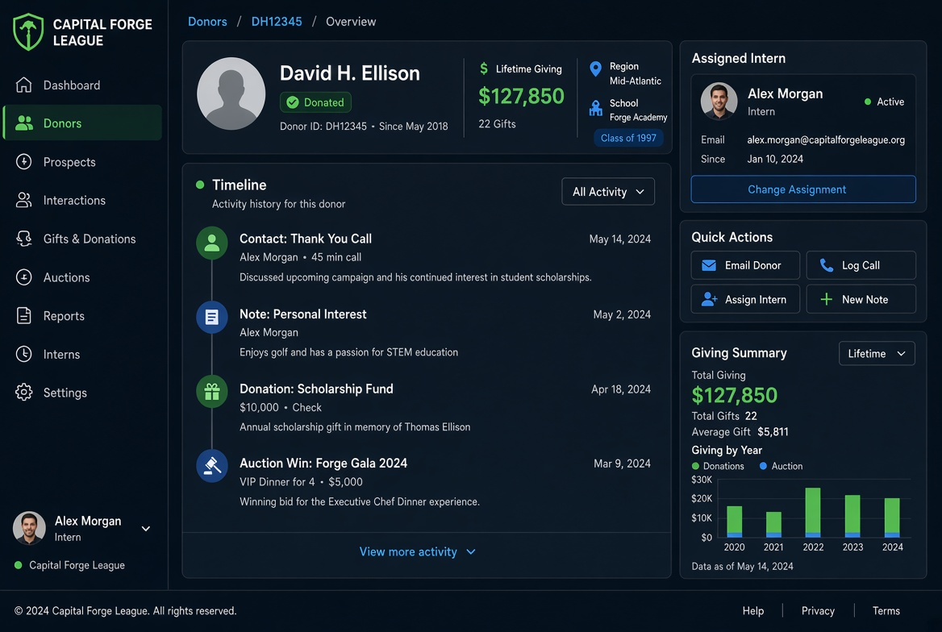

3.8 Donor Tracking & Analytics (dashboard)
Portfolio view for interns/admins: totals, active this month, average gift, retention rate, engagement scores, filters, saved segments.
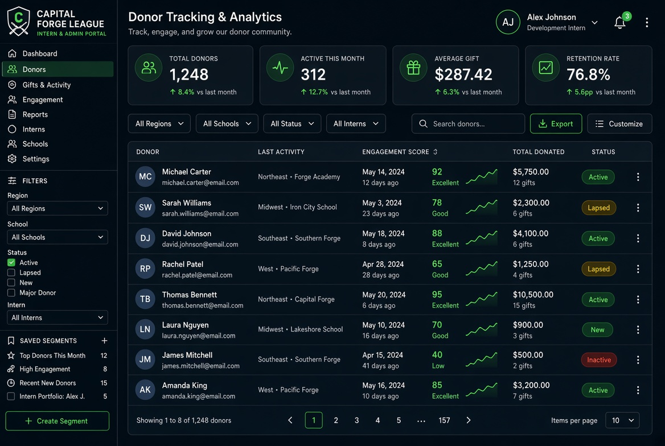

4. Architecture Snapshot
Stack: Laravel 11 (PHP 8.3) • Livewire 3 • Laravel Reverb (WebSockets) • Stripe (Cashier or direct) • Spatie Permission + Media Library • Tailwind CSS (dark neon theme) • Redis / Horizon queues • AI Vision (xAI Grok / OpenAI GPT-4o)
Core Models: User (roles: Admin, Intern, Bidder), Auction, Lot (ai_analysis JSON), Bid, Campaign, Donor (region_id, school_id, assigned_intern_id, status), Donation, Region, School, Interaction/Note.
Key Design Decisions: Heavy use of JSON columns for AI results, bid history snapshots, and widget configs. Real-time channels scoped by auction/lot and by campaign for progress. All payments go through Stripe; auction wins create PaymentIntents or Checkout Sessions automatically on close.

5. Real-time with Laravel Reverb
Laravel Reverb provides first-party WebSocket support. It is used for live bid updates, outbid notifications, and the public progress / live-display feed.

Installation & Config (excerpt)
composer require laravel/reverb
php artisan reverb:install
// .env
REVERB_APP_ID=...
REVERB_APP_KEY=...
REVERB_APP_SECRET=...
REVERB_HOST=localhost
REVERB_PORT=8080
REVERB_SCHEME=http
BROADCAST_CONNECTION=reverb

Broadcast Event Example
// app/Events/BidPlaced.php
class BidPlaced implements ShouldBroadcast
{
use Dispatchable, InteractsWithSockets, SerializesModels;
public function __construct(public Bid $bid) {}
public function broadcastOn(): array
{
return [
new Channel('lot.'.$this->bid->lot_id),
new Channel('auction.'.$this->bid->lot->auction_id),
];
}
public function broadcastWith(): array
{
return [
'id' => $this->bid->id,
'amount' => $this->bid->amount,
'user' => $this->bid->user->name,
'lot_id' => $this->bid->lot_id,
'created_at' => $this->bid->created_at->toIso8601String(),
];
}
}
On the frontend (Livewire + Alpine / Echo), listen on the private or public channel and update the current high bid, bid history list, and any progress widgets in real time without a page refresh.

6. Stripe Payment Processing
Two primary flows: (1) Immediate payment for “Buy Now” or donations, (2) Post-auction collection for winning bids. Laravel Cashier can be used, or the official Stripe PHP SDK for more control over PaymentIntents and Checkout Sessions.

Recommended Approach
- Store Stripe Customer ID on the User / Donor model
- On auction close: create PaymentIntent for the winning amount (or send Checkout Session link)
- Webhook endpoint (Stripe webhook → Laravel) marks Donation / Bid as paid and updates donor totals
- Support card, Apple Pay, Google Pay, ACH where appropriate
// Example: create PaymentIntent after auction ends
$intent = \Stripe\PaymentIntent::create([
'amount' => (int)($winningBid->amount * 100),
'currency' => 'usd',
'customer' => $user->stripe_id,
'metadata' => [
'lot_id' => $lot->id,
'bid_id' => $winningBid->id,
'auction_id' => $lot->auction_id,
],
'description' => 'CFL Auction Win: '.$lot->title,
]);

7. Livewire Component Code
Livewire 3 is used for reactive UI without heavy SPA complexity. Below are key components.

7.1 BidForm Component
// app/Livewire/BidForm.php
namespace App\Livewire;
use App\Models\Lot;
use App\Events\BidPlaced;
use Livewire\Component;
use Illuminate\Support\Facades\Auth;
class BidForm extends Component
{
public Lot $lot;
public $amount;
public $maxProxy = null;
public $useProxy = false;
protected $rules = [
'amount' => 'required|numeric|min:0.01',
];
public function mount(Lot $lot)
{
$this->lot = $lot;
$this->amount = $lot->current_bid + $lot->bid_increment;
}
public function placeBid()
{
$this->validate();
$min = $this->lot->current_bid + $this->lot->bid_increment;
if ($this->amount < $min) {
$this->addError('amount', "Minimum bid is $" . number_format($min, 2));
return;
}
$bid = $this->lot->bids()->create([
'user_id' => Auth::id(),
'amount' => $this->amount,
'is_proxy' => $this->useProxy,
'max_proxy' => $this->useProxy ? $this->maxProxy : null,
'status' => 'active',
]);
$this->lot->update(['current_bid' => $this->amount]);
// Anti-snipe extension
if ($this->lot->ends_at->diffInMinutes(now()) < 5) {
$this->lot->update(['ends_at' => $this->lot->ends_at->addMinutes(5)]);
}
broadcast(new BidPlaced($bid))->toOthers();
$this->dispatch('bid-placed');
$this->amount = $this->lot->fresh()->current_bid + $this->lot->bid_increment;
}
public function render()
{
return view('livewire.bid-form');
}
}

7.2 LiveProgress Component (public)
// app/Livewire/LiveProgress.php
class LiveProgress extends Component
{
public $campaignId;
public $totalRaised = 0;
public $goal = 250000;
public $bySchool = [];
public $byRegion = [];
public $recent = [];
protected $listeners = ['echo:campaign.{campaignId},DonationReceived' => 'refresh'];
public function mount($campaignId)
{
$this->campaignId = $campaignId;
$this->refresh();
}
public function refresh()
{
// Aggregate queries (cached or optimized)
$this->totalRaised = Donation::where('campaign_id', $this->campaignId)->sum('amount');
$this->bySchool = /* groupBy school_id with joins */;
$this->byRegion = /* groupBy region_id */;
$this->recent = Donation::with('donor')->latest()->take(10)->get();
}
public function render()
{
return view('livewire.live-progress');
}
}

7.3 DonorTimeline Component
// app/Livewire/DonorTimeline.php
class DonorTimeline extends Component
{
public Donor $donor;
public $note = '';
public function addNote()
{
$this->donor->interactions()->create([
'user_id' => auth()->id(),
'type' => 'note',
'body' => $this->note,
]);
$this->note = '';
$this->donor->refresh();
}
public function render()
{
return view('livewire.donor-timeline', [
'items' => $this->donor->interactions()->latest()->get()
]);
}
}

8. Donor Tracking Enhancements
Beyond the basic driving CRM, the system includes dedicated tracking screens (mockups 07 & 08) that give interns and admins a complete view of each relationship and portfolio performance.
- Engagement Score: Composite of recency, frequency, monetary value, and interaction quality.
- Activity Timeline: Unified feed of calls, emails, notes, donations, and auction activity.
- Intern Portfolio: Each intern sees only their assigned donors with clear next-action prompts.
- Saved Segments: “Top donors this month”, “Lapsed major donors”, “New this campaign”, etc.
- Retention & Analytics: Month-over-month active donors, average gift, retention rate cards.

9. Implementation Roadmap
- Phase 1 – Foundation (1–2 weeks): Laravel scaffold, auth + Spatie roles, core migrations (Auction/Lot/Bid/Donor/Region/School), Tailwind dark theme, basic admin CRUD.
- Phase 2 – Auction Core (2 weeks): Lot management, bidding logic, anti-snipe, Reverb channels, BidForm Livewire component, public auction pages.
- Phase 3 – AI + Payments (1–2 weeks): AiLotAnalyzer service (start with mock, then wire vision API), Stripe PaymentIntent / Checkout + webhooks, winner collection flow.
- Phase 4 – Donor Driving & Tracking (2 weeks): CSV import, assignment UI, status pipeline, DonorTimeline + analytics screens, intern portfolio views.
- Phase 5 – Progress & Live Display (1 week): Public progress dashboard, LiveProgress component, full-screen Live Display route, embeddable widgets.
- Phase 6 – Polish & Launch: Notifications (email/SMS), reporting exports, security review, staging → production.

10. Next Steps & Handoff
This document, together with the accompanying PNG mockups and the starter code already generated (Lot & Donor models, AiLotAnalyzer, migration), constitutes a complete technical proposal ready for development.
Recommended immediate actions for the development team (Lavlesh / CFL engineering):
- Review mockups and confirm any branding adjustments (exact neon hex values, logo treatment).
- Provision Stripe account (test + live keys) and Reverb / Redis infrastructure.
- Decide vision provider (xAI Grok Vision preferred for CFL alignment, or OpenAI).
- Begin Phase 1 scaffold and share repository access.
Prepared by Grok for Capital Forge League • August 2026
All mockups and code samples are provided for internal implementation use.

